2277 – Capstone – Python for Generative AI

Module 01: Introduction
- AI – a general-purpose technology
- Artificial intelligence (AI) technology is transformative, significantly impacting the economy and the business world by altering business processes across a wide range of industries.
- Examples AI technologies include:
- Deep learning and associated innovations
- Natural language processing (NLP) and
- machine learning
- Generative pre-trained transformers (GPT)
- These AI technologies influence diverse sectors, from healthcare and education to enterprise automation.

- The tasks that LLMs can perform
- Text Generation: Create coherent and contextually relevant text for various applications, such as articles, stories, and marketing content.
- Language Translation: Automatically translate text between different languages, maintaining meaning and nuance.
- Summarization: Condense long documents or articles into concise summaries, capturing the essential information.
- Sentiment Analysis: Analyze text to determine the sentiment (positive, negative, neutral) behind the words.
- Question Answering: Provide accurate and context-aware answers to user queries, often based on vast amounts of information.
- Text Completion: Predict and generate the next sequence of words in a text, useful for autocompletion in writing tools.
- Content Personalization: Tailor content recommendations and interactions based on individual user preferences and behavior.

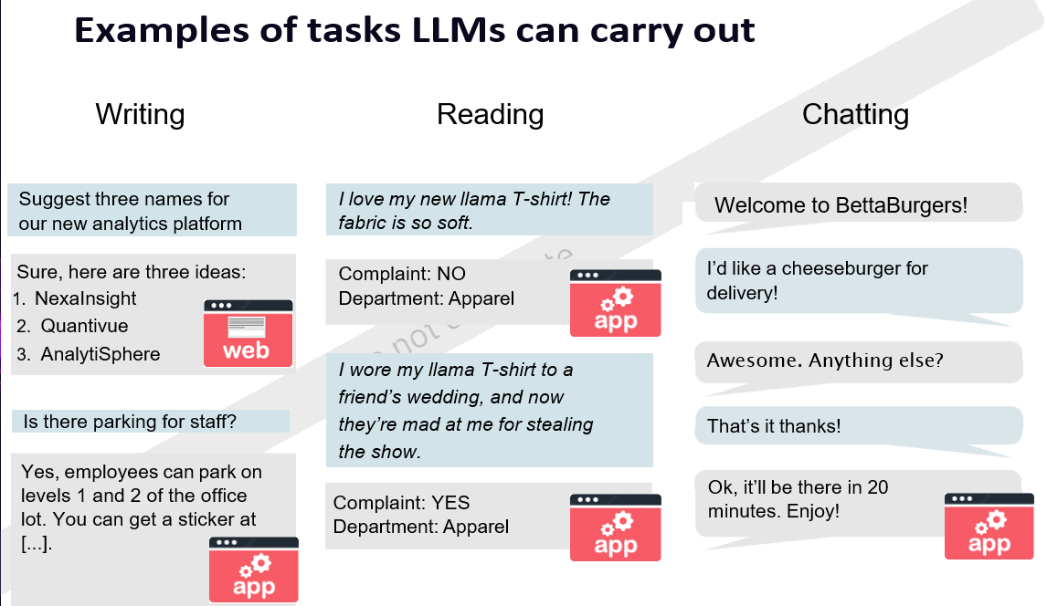
- Web-based LLMs vs App-based LLMs

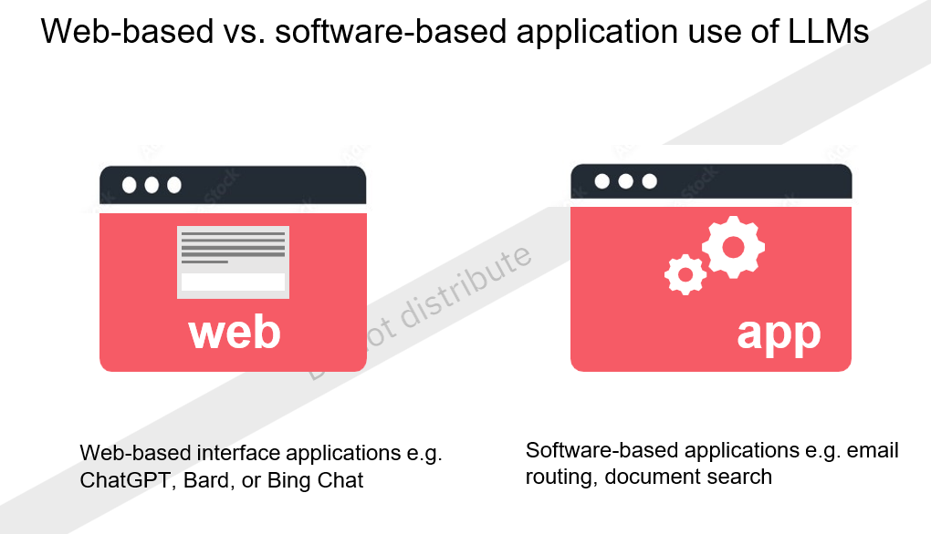
- Why GenAI for Organizations & Employees?

- Organizations:
• Digitized operational knowledge is a valuable asset
• Operational and historical data can be made available to wider user groups with simple humanly interaction with GenAI
• Information can be available in multiple formats – Summary, bullet points, graphs, audio etc.

- Employees:
• Able to absorb huge volumes of data, interpret and take actions quickly
• Helps decision making faster that leads to competitive advantage

- The future of prompt engineering

As AI technology evolves, prompt engineering
will become even more crucial.
We can expect:
1. More sophisticated techniques - Development of advanced approaches for handling complex tasks and emotions.
2. Integration with other AI tools - Seamless combination of prompt engineering with other AI techniques for enhanced capabilities.
3. User-friendly interfaces - Tools that make prompt engineering accessible even to non-technical users.

